Project Title: Light

Team Members: Mphatso Simbao

Repository: [https://github.com/msimbao/light\](https://github.com/msimbao/light%5C)

Class: COMP 123 - 04

Professor: Susan Fox

# Section 1: Background and User’s Manual

I have always being interested in physiotherapy for patients in hospitals and finding ways to improve their mood and mental health. This is because encouraging patients to have a positive outlook is important for serving them while they recover

[1]. My mom is a physician and I wanted to think of interesting uses of technology to serve caregivers and patients by using light of different wavelengths to create positive effects in the hospitals. It is meant to be operated by nurses that will be monitoring patients or the patients’ family members. It also has a habit tracker to help caregivers keep track of positive changes a patient needs to make during their rehabilitation.

The device is a machine that changes the lighting of a room based on what the occupants of the room need to provide different healing effects to the patient's body. This type of Chromotherapy has been in existence since 2000 BCE when the Egyptians and hemetican Greeks had treatment sanctuaries with rooms of different colors which had different healing qualities [2]. Of late, modern studies reported by the New York times and even MIT’s Richard J.Wurtman has shown that individual colors can treat premature babies of jaundice (30,000 children are treated each year instead of having dangerous blood transfusions), prevent black lung disease, improve work ability and even reduce aggression in violent juveniles [2].

The lamp was made using a wooden box painted white with a 3D printed geometric dog I designed. The lamp was meant to be minimalist but aesthetically pleasing and the 3D image can be anything depending on the preference of the user. IT just creates something nice to look at. It uses an RGB Led to emit light of different colors as well as a UV sterilizer lamp to emit disinfecting UV light in a room. The entire program runs using a GUI built using the tkinter module in python.

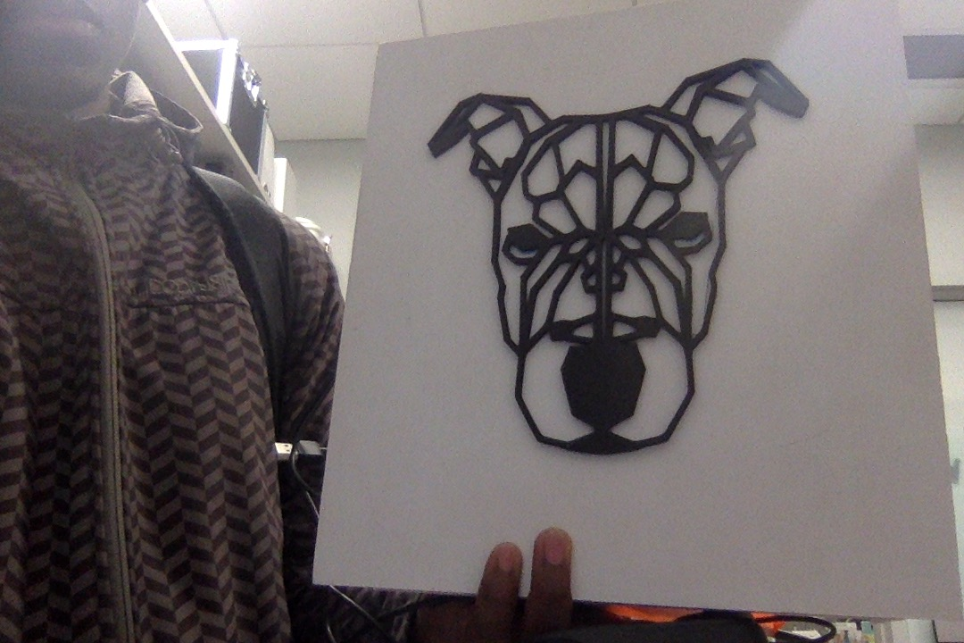

Pre-requisites:

To Run the device, you will need a [Raspberry Pi](https://www.amazon.com/Raspberry-Pi-MS-004-00000024-Model-Board/dp/B01LPLPBS8) [3] (you will need a monitor, keyboard and mouse as well incase you do not have them), Pi-T Cobbler [4] and breadboard and [Sunfounder Sensor Kit](https://www.sunfounder.com/rpi2-sensorv2.html) [5].

Connect the 3 sunfounder modules using the explanations found on the sunfounder tutorials pages:

1. RGB LED module [6]
2. LCD Display [7]
3. Relay Module [8]

Additionally, you will need a [UV lamp](https://www.amazon.com/Sterilization-Waterproof-Control-7-inch-Ultraviolet/dp/B07KVM9LSB/ref=sr_1_1_sspa?keywords=uvc+lamp+sunny+smell&qid=1557287755&s=gateway&sr=8-1-spell-spons&psc=1) [9] that will be connected to the relay module instead of the led shown on the tutorial website. A rough prototyping setup of the connections is shown below:

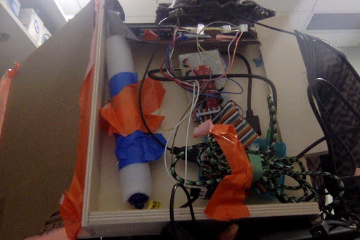

The next steps will be done on your raspberry pi.

To run the program:

1. Go to the github repository [https://github.com/msimbao/light\](https://github.com/msimbao/light%5C) using your raspberry pi’s web browser
2. Download the files by clicking the green “clone or download” button.
3. Click “Download Zip” in the drop down menu that appears.
4. Right click the downloaded zip file and select “unzip”. Once it is done, open the file and navigate to the “Mphatso’s Project” directory.
5. Open the final.py file using a python IDE such as Thonny (for the Raspberry Pi) or pyCharm (if using a PC or MAC).
6. At the top of each IDE, there should be a “play” or “run” button that you can click to start the program

Once the program is open, a GUI window will pop up on the screen with a simple welcome message. An example is shown below:

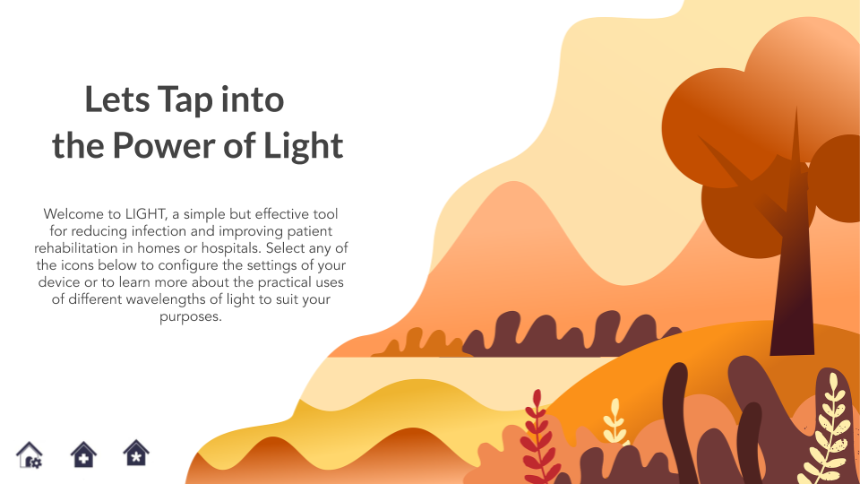

There will be three buttons at the bottom of the GUI, the first takes you to the settings page, the second takes you to a window that has colored boxes and the last one ends the program.

If you go the settings page, clicking any of the colored rectangles will change the color of the LED. Clicking the buttons under timing will set the LED to cycle through each color at an interval equal to the time specified on the button. Clicking the ‘1 hour’ button under the UV time section will run the UV lamp for 1 hour to disinfect a room. The settings page is shown below:

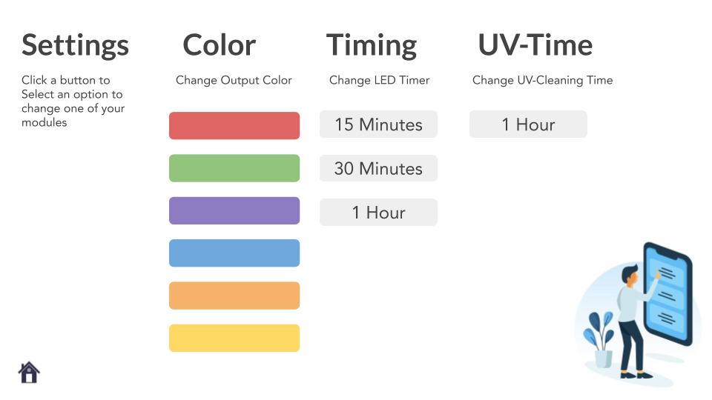

If you go to the colors page, a 6x2 grid with colored boxes will appear. Clicking any of the colored squares will open a window with an explanation of the scientific medical use of that specific color. These pages are meant to help caregivers decide on what color of light might be best for a patient depending what the patient needs at that time. The color’s page is shown below as well as an example of the ‘orange’ color window that explains that orange light might be best for helping stimulate a patient’s appetite and increase the amount of oxygen their brain receives.

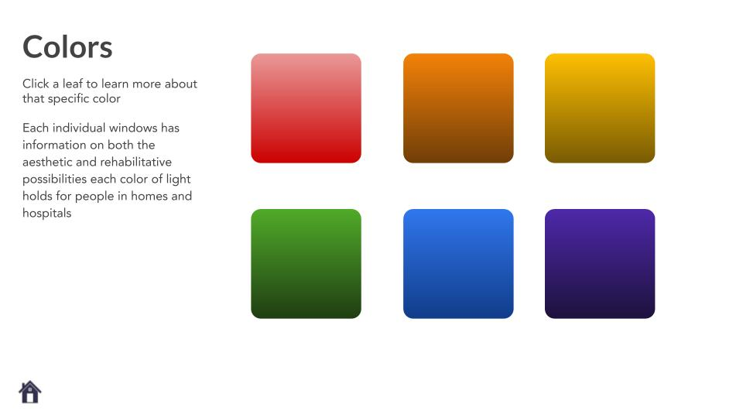

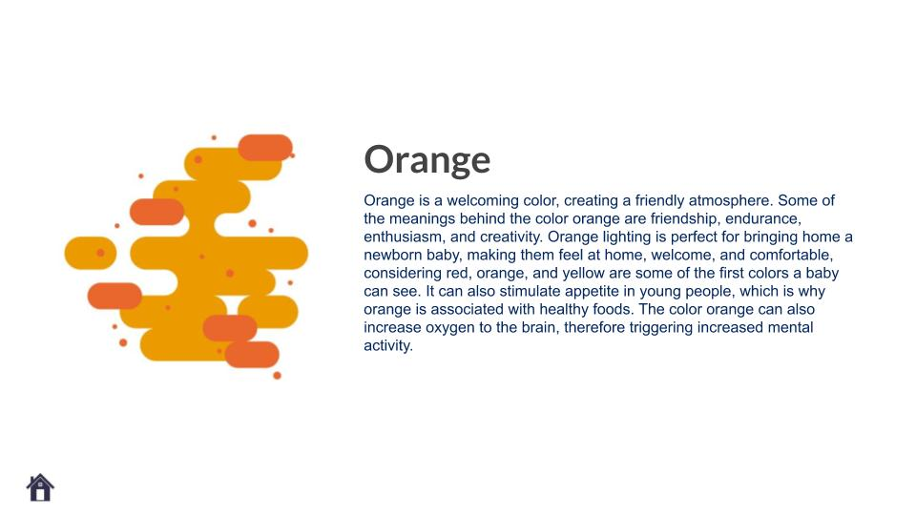

Each window has a button at the bottom that will close the window when you are done with it.

# Section 2: Contents of Program

The program runs using 2 files and 3 folders. The first folder contains Images that were made using google slides and are the main backgrounds used to create the GUI. The second folder contains a memory txt file that records the number of days a patient has stuck to a positive habit that they are trying to build. The final folder contains an mp3 file which is used as background music when the GUI is open.

The first python file (LCD1602.py) contains helper functions for the LCD display that help us turn it on, off and display messages to our patients. This module was provided by Sunfounder and i did not write it but implement the functions inside the final.py file that I wrote.

This has a main function that gives an example of how to use the init and write functions:

1. Puts the LCD display in an initial state (either have the LED backlight on or off, decide how many characters to display for the top and bottom lines)
2. Write ‘Hello’ on the first line (index 0) as an example call
3. Write ‘World!’ on the second line (index 1) as an example call

The write word function is the main helper function that is used to build the send_command and send_data functions. The send_command and send_data functions both interact directly with the LCD display’s matrix and are used to manipulate each ‘pixel’ to display different characters.

The send_command function is used to create the ‘init’ function that sets the initial state of the LCD’s character matrix. It is also used to write the ‘clear’ function that clears the screen. Finally, it is used together with the send_data function to make the ‘write’ command’ that displays a string on a line of the LCD.

The file also contains the openlight function that takes no inputs but turns the LED backlight on.

The final.py file that I wrote first contains several import statements for the important modules that are used to run the program:

1. import pygame : Needed to run background music
2. import tkinter as tk : Needed to make the GUI
3. import PIL : Needed for image manipulation
4. import PIL.Image as Image : Needed for image manipulation
5. import PIL.ImageTk as ImageTk : Needed for image manipulation
6. import RPi.GPIO as GPIO : Needed to communicate with Raspberry pi GPIO pins
7. import time: Needed to create a queue for the LED color changes
8. import LCD1602 : Needed to operate the LCD module.

It also begins by setting the values of important variables like the position of the GPIO pins for the sunfounder modules and loading the memory text file for the habit tracker.

The main function creates the tkinter window and initiates and controls the Sunfounder modules. It does this uses helper functions that are written at the start of the file.

For the sunfounder module, the ‘setup’ function helps the main function by turning all the GPIO pins on and assigning them to their respective module pin numbers. The ‘off’ and ‘destroy’ functions do the opposite and turn the GPIO pins off and destroy the connection that the modules have to the Raspberry pi. The ‘map’ and ‘setColor’ functions are used to change the colors of the RGB led module. The ‘loop’ function is used to create a color changing queue setting for the RGB led.

The main function contains classes for each tkinter window and basic functions that open/close those windows as well as other windows. These functions are handled by buttons placed on the screens. The classes also contain basic labels that are set to display background images to make the GUI for each window.

The main window contains calls to the sunfounder module functions to initialize the modules. It calls: ‘setup’, ‘LCD1602.init’, ‘LCD1602.write’ and ‘setColor’. In the initialization step, the LCD is set to display: “Hello! (ﾉ◕ヮ◕)ﾉ*:･ﾟ✧’.

It also uses the pygame module to setup some background music for the GUI as long as the main window is open. It also contains a habit tracker button that adds a count of 1 to the habit tracker file and displays the number of days that have been counted so far. It can only be updated once each time the program is turned on. The button for it is hidden on the top left of the introductory message on the main screen so that only the caregiver knows where it is. The button is white but turns into an orange box when hovered over.

To test the program, I could not write test files but had to manually operate the device. I am confident that the GUI worked completely and that the modules functioned as required. The GUI windows all opened and closed as required and displayed the information they had without errors. The settings window functions also worked without errors and could change the RGB led colors as required and turn the UV lamp on and off. The habit tracker also worked as required and displayed the information from the hait_tracker memory file without error. The only thing i couldn’t test was the pygame background music because i did not know how to get sound output from the raspberry pi at the time.

# Section 3: Conclusion

I am really thankful for getting to do this project as I got to have a hand at programing using soft-hardware and learnt a lot about the raspberry pi, unix systems and product design. A lot of things surprised me especially trying to get the sunfounder modules to work. I also thought i would be able to get openCV to work for the raspberry pi but it was surprisingly hard to set up as i kept getting a lot of errors. The UV lamp was also difficult to test because it was dangerous to look directly at while working with if it was on. Next time I would spend less time on the hardware so i can have more time to go really complex on the capabilities of the main program using very little hardware components. I think that could help my project do more and I can expand on hardware later rather than starting big and ending up small.

Future extensions will include:

1. Adding computer vision to detect the mood and context of the patient using google vision ai and change the color accordingly (e.g if no one is around, turn on the UV lamp or if it's time to sleep change the color to red and slowly turn it off as the patient falls asleep.)
2. Add more personalization features to the settings window.
3. Make the lamp design more aesthetic and friendly.
4. Make everything smaller and more compact for users.

# Section 4: Bibliography

1. <https://www.nytimes.com/2017/03/27/well/live/positive-thinking-may-improve-health-and-extend-life.html>
2. <https://www.nytimes.com/1982/10/19/science/color-has-a-powerful-effect-on-behavior-researchers-assert.html>
3. <https://www.amazon.com/Raspberry-Pi-MS-004-00000024-Model-Board/dp/B01LPLPBS8>
4. <https://www.adafruit.com/product/2028?gclid=EAIaIQobChMIvIDNsvGd4gIVjLXACh23YQKlEAQYBSABEgIvhvD_BwE>
5. [https://www.sunfounder.com/rpi2-sensorv2.htm](https://www.sunfounder.com/rpi2-sensorv2.html)l
6. <https://www.sunfounder.com/learn/sensor-kit-v2-0-for-raspberry-pi-b-plus/lesson-2-rgb-led-module-sensor-kit-v2-0-for-b-plus.html>
7. https://www.sunfounder.com/learn/sensor-kit-v2-0-for-raspberry-pi-b-plus/lesson-30-i2c-lcd1602-sensor-kit-v2-0-for-b-plus.html
8. https://www.sunfounder.com/learn/sensor-kit-v2-0-for-raspberry-pi-b-plus/lesson-4-relay-module-sensor-kit-v2-0-for-b-plus.html
9. https://www.amazon.com/Sterilization-Waterproof-Control-7-inch-Ultraviolet/dp/B07KVM9LSB/ref=sr_1_1_sspa?keywords=uvc+lamp+sunny+smell&qid=1557287755&s=gateway&sr=8-1-spell-spons&psc=1